PROPHESIES FULFILLED – THE EUPHRATES
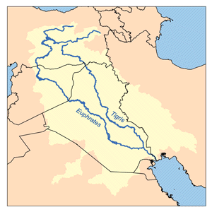
More Last Days prophesies are being fulfilled - Roelof

And the sixth angel poured out his vial on the great river Euphrates. And its water was dried up, so that the way of the kings from the rising of the sun might be prepared. (Rev 16:12)

(The Last Days started in 1989, 22 years ago. The End Times started with the Ascension of Christ – Roelof)

Since 2003, the Tigris and Euphrates water levels have steadily receded to a record low.

The former green ribbon of fertile land between the Tigris and Euphrates, which existed only 20 years ago, is now disappearing and transforming into desert.

http://reliefweb.int/node/362880

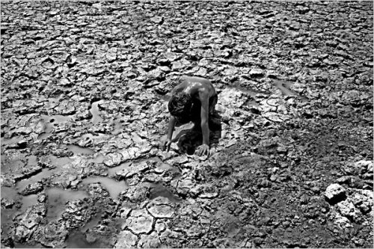

http://flashtrafficblog.wordpress.com/2009/07/16/euphrates-river-drying-up-new-york-times-notes-prophetic-implications/

http://www.nytimes.com/2009/07/14/world/middleeast/14euphrates.html

And the number of the armies of the horsemen was two myriads of myriads (two hundred million). And I heard their number. (Rev 9:16)

Chinese soldiers headed to Middle East?

China is considering setting up military bases and possibly deploying forces in the Middle East over the next decade as a means of protecting its access to strategic materials, especially oil, and sizeable investments in various Arab countries

http://www.wnd.com/index.php?fa=PAGE.view&pageId=121736

Dear friend

Are you ready for the Second Coming of Christ?

It is now 22 years since the start of the Last Days in 1989, all the signs are there and the prophesies fulfilled, the Second Coming could happen any day.

Greetings

Roelof Coertze
South Africa

