LAST DAYS – HOW CLOSE IS THE SECOND COMING? --- NATURAL DISASTERS

Natural disasters are a sign of the Second Coming of Christ. The earth is testifying of the Return of Christ. I expect the Second Coming of Christ from 2015 onwards - Roelof

And as He sat on the Mount of Olives, the disciples came to Him privately, saying, Tell us, when shall these things be? And what shall be the sign of Your coming, and of the end of the world? (Mat 24:3)

for then shall be great tribulation, such as has not been since the beginning of the world to this time; no, nor ever shall be. (Mat 24:21)

From Nelson’s New Illustrated Bible Dictionary:
THE GREAT TRIBULATION— a short but intense period of distress and suffering at the end of time. The exact phrase, “the great tribulation,” is found only once in the Bible (Rev. 7:14). The great tribulation fulfills Daniel’s prophecies (Daniel 7–12). It will be a time of evil from false christs and false prophets (Mark 13:22) when natural disasters will occur throughout the world.
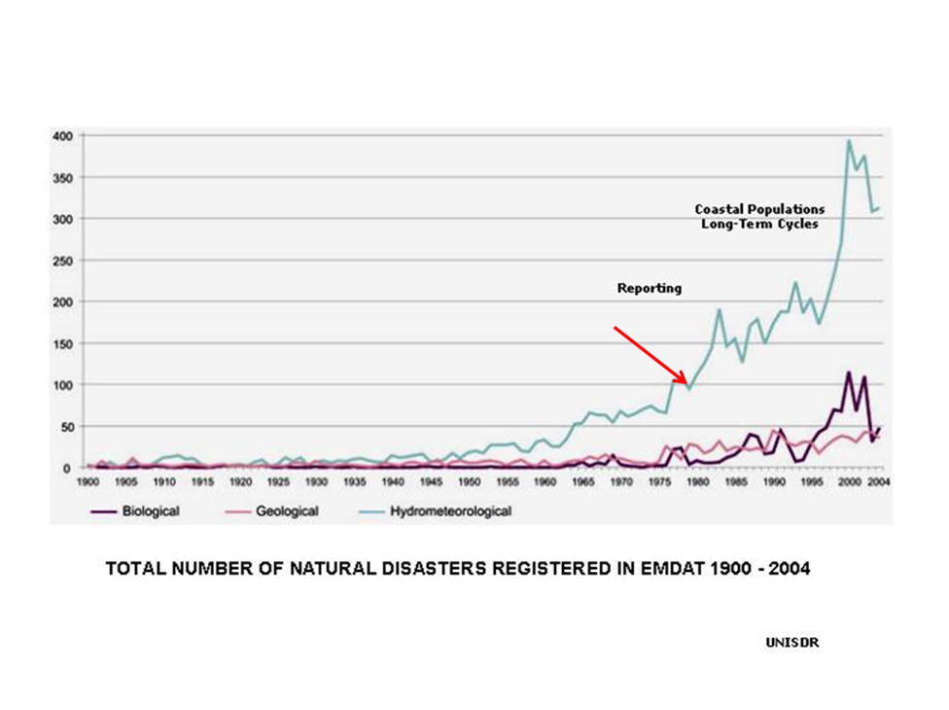

http://www.geo.umass.edu/courses/geo250/ndtvul.htm

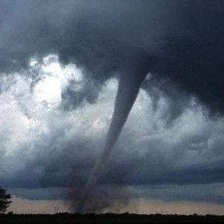
Record 312 twisters in single day, US says
It looks like last week's tornado outbreak was the biggest on record for a single 24-hour period, federal experts said Monday.
http://www.msnbc.msn.com/id/42863493/ns/weather/

http://www.cnsnews.com/news/article/southern-tornado-outbreak-could-be-large

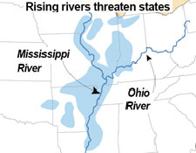
All Eyes on the Mississippi River
The Mississippi River continues to rise, so much so that its tributaries are starting to flow backwards.

http://www.myfoxmemphis.com/dpp/weather/all-eyes-on-the-mississippi-river-rpt-20110428

New 9.4 EARTHQUAKE rocks Japan

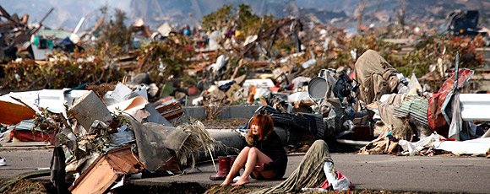
http://www.time.com/time/specials/packages/0,28757,2058716,00.html

Euphrates River drying up

And the sixth angel poured out his vial on the great river Euphrates. And its water was dried up, so that the way of the kings from the rising of the sun might be prepared. (Rev 16:12)

http://frankdimora.typepad.com/the_last_chronicles/2010/10/euphrates-river-drying-updroughtsyria-and-irans-alliancegold-and-silver-newscivil-unrest-in-francewar-signseconomic-dec.html

http://answers.yahoo.com/question/index?qid=20110422171610AAeqbqt

http://wn.com/euphrates_river_drying_up_rapidly

Dear friend

Are you ready for the Second Coming of Christ?

Have you accepted Jesus Christ as Saviour?

Greetings

Roelof Coertze

South Africa

